**Constants for Service Calls:**

(I don’t really know what they all mean, but these constants are set on the Java SOAP client objects before invoking QAS. These might modify the behavior of QAS responses.)

Layout: “MBP”

Flatten = true

Threshold: 200

Intensity: EngineIntensityType.Close

set_value(EngineEnumType.Verification);

setPromptSet(com._18fqas.www.PromptSetType.Optimal);

search.setFormattedAddressInPicklist(false);

**QAS Pseudocode**

1. On post of the recipient info form
   1. build search string according to sample code below. Figure 1
   2. call doSearch
   3. Check Verify Level returned in response. (For detailed descriptions of verify levels, refer to the section below
      1. If “Verified,” then pull the address out of the response and save to the order. No need to prompt the user.
      2. if “User Interaction Required,” then pull address from the response and display to customer. Ask him to confirm that this single address is correct.
      3. For Verify Levels, Multiple, PremisesPartial, and StreetPartial suggestions are returned, in the form of a “Pick List.” Display the suggestions to the customer. The website hides these by default and allows the user to show them to scroll through all the suggestions. Each suggestion will have meta data. It will tell you if it’s a range or a full address. It will also have a moniker, which needs to be sent back to QAS in the refine and doGetAddress calls - if the user picks it.
2. While displaying suggestions on the address verify page see Figure 1.
   1. If the user clicks a full address
      1. Call doGetAddress and retrieve the full address from QAS. The address returned in the pick list is just a display value. You need to call this method to get the fields broken out properly. Immediately move to the next page.
   2. If the Customer picks a range, then prompt the user to enter the street or apartment number.
      1. Call doRefine with value entered by the customer and the moniker from the suggestion.
      2. If verify level is NONE, then the value entered is no good. “The Street/Apt No you have entered could not be found. Please refer the list of options below.”
      3. If there is a single suggestion returned in the picklist, and it’s a full address, then call doGetAddress with the monitor.

|  |
| --- |
| public String getSearchString()  {  StringBuffer buffer = new StringBuffer();  buffer.setLength(BigDecimal.ZERO.intValue());  String addressSeperator = ",";    if (StringUtils.isNotEmpty(getOrganizationName())) {  buffer.append(getOrganizationName()).append(addressSeperator);  containsCompany = true;  }  if (StringUtils.isNotEmpty(getAddressLine1()))  buffer.append(getAddressLine1()).append(addressSeperator);  if (StringUtils.isNotEmpty(getAddressLine2())){  buffer.append(getAddressLine2());  if (StringUtils.isNotEmpty(getAddressLine3())){  buffer.append(" ").append(getAddressLine3()).append(addressSeperator);  }  else  {  buffer.append(addressSeperator);  }  }  if (StringUtils.isNotEmpty(getCity())){  buffer.append(getCountry().equalsIgnoreCase(QASConstants.COUNTRY_USA.attribute) ? "@c" : FDCheckoutConstants.EMPTY_STRING);  buffer.append(getCity()).append(addressSeperator);  }  if (StringUtils.isNotEmpty(getState() )){  buffer.append(getState()).append(addressSeperator);  }  if (StringUtils.isNotEmpty(getZipCode())){  buffer.append(getZipCode());  }    return buffer.toString();  }  } |

Figure 1 Sample code to create search string

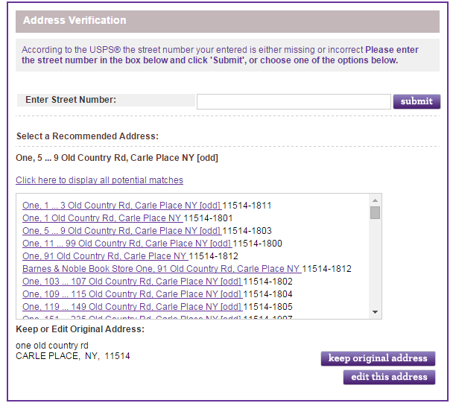

Figure 2 Screenshot of picklist suggestions being displayed on the website

Verify Level

**Single verified address result. Verify level: "Verified".**

The address searched upon was matched to a single deliverable address in the QuickAddress data. The verified result may be slightly different from the address entered and searched upon, as any formatting and spelling errors will have been corrected, and any missing elements will have been added. When this match type is returned, no further user interaction is required and no picklists will be displayed to the user for further selection. This is represented by the non-shaded path in the diagram on page 29.

**Single unverified address result. Verify level: "User interaction required".**

The address searched upon was matched to a single deliverable address in the QuickAddress data, although the engine is less confident about the match than for the "Verified" level above, and therefore user interaction is recommended to confirm that it is the correct address. Although user interaction is required when this match type is returned, no picklists are displayed for selection. This is represented by the (Accept) As Found and (Accept) As Entered sections of the Interaction Page in the diagram on page 29.

**Single partial address result. Verify level: "PremisesPartial".**

The address searched upon was not matched to a complete deliverable result in the QuickAddress data, and instead has been matched to a partially-complete address. For example, the Verification engine may have matched the address to a premises in the QuickAddress data, such as "63 Southerton Road, London" but may not have been able to find a deliverable match: "Flat A, 63 Southerton Road, London". A picklist is returned containing a range of partially matched premises, and user interaction is therefore needed to select the required address. This is represented by the (Select from) Picklist section of the Interaction Page in the diagram on page 29. Alternatively, if you do not want to use picklists, the presence of a partial address result will indicate that the address that was searched on has not been verified. You could use the original address that was entered and flag the record as an unverified match. This is represented by the (Accept) As Entered section of the Interaction Page in the diagram on page 29. 33

**Single partial address result. Verify level: "StreetPartial".**

The address searched upon was not matched to a complete deliverable result in the QuickAddress data, and instead has been matched to a partially-complete address. For example, the Verification engine may have matched the address to a street in the QuickAddress data, but may not have been able to find a deliverable premises match: "Kew Road, Richmond" rather than "88 Kew Road, Richmond". A picklist is returned containing a range of partially matched streets and user interaction is therefore needed to select the required address. This is represented by the (Select from) Picklist section of the Interaction Page in the diagram on page 29. Alternatively, if you do not want to use picklists, the presence of a partial address result will indicate that the address that was searched on has not been verified. You could use the original address that was entered and flag the record as an unverified match. This is represented by the (Accept) As Entered section of the Interaction Page in the diagram on page 29.

**Multiple address matches. Verify level: "Multiple".**

The address searched upon was not matched to a single deliverable result in the QuickAddress data, and instead has matched equally to more than one result. For example, the Verification engine may find two equally valid addresses that can only be distinguished by address information that has not been provided in the search. The results may or may not be deliverable addresses, and may or may not need to be stepped into to generate a picklist. As there will be multiple results returned by the Verification engine, Pro Web will not automatically step into any of the results, but instead will return a picklist containing the matches. Further user interaction is therefore necessary to select the required address. This is represented by the (Select from) Picklist section of the Interaction Page in the diagram on page 29. If you do not want to use picklists, the presence of multiple address results will indicate that the address that was searched on has not been verified. You could use the original address that was entered and flag the record as an unverified match. This is represented by the (Accept) As Entered section of the Interaction Page in the diagram on page 29.

**No address result. Verify level: "None".**

The address searched upon could not be matched to any deliverable results in the QuickAddress data. When this match type is returned, no address verification is possible and the submitted address should be used instead.